ReserveIt
Security Report: Analysis of OWASP Top 10 Security Risks

1. Broken Access Control (A01:2021)
Implementation Analysis
The application implements several access control mechanisms:
- Role-Based Access Control (RBAC):
  - Uses Spring Security with @PreAuthorize annotations
  - Defined roles: ADMIN, MANAGER, STAFF, CUSTOMER
  - Example from SecurityConfig.java:
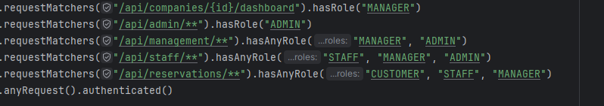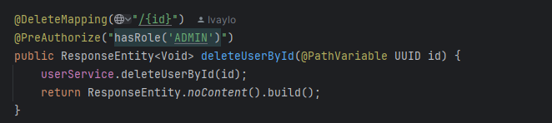
2. JWT Authentication:
- JWT tokens contain user role and company ID
- Token validation in JwtAuthFilter.java

Critical Case Study: Customer Data Access Control
Question: Can user A access or modify user B's data if they both have CUSTOMER role?
Answer: The application has some protections but also vulnerabilities:
Protected Areas:
- Reservation Access:
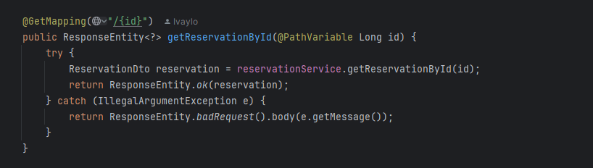
Vulnerability: There's no explicit check that the requesting user owns the reservation. A malicious customer could potentially access other customers' reservations by guessing IDs.
Possible Fixes:
- Add user ownership verification:
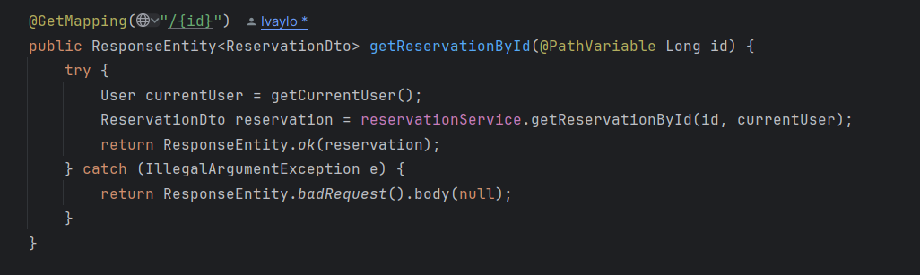
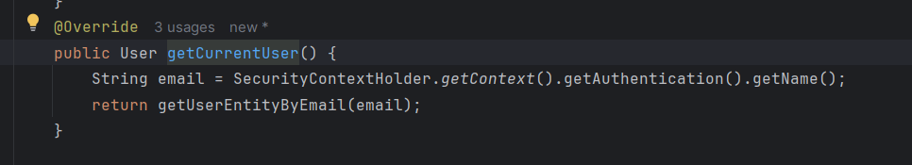
2. SQL Injection (A03:2021)
Implementation Analysis
The application uses JPA/Hibernate with Spring Data JPA, which provides significant protection against SQL injection by default:

- Parameterized Queries:

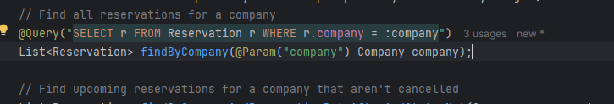

- Entity Management:
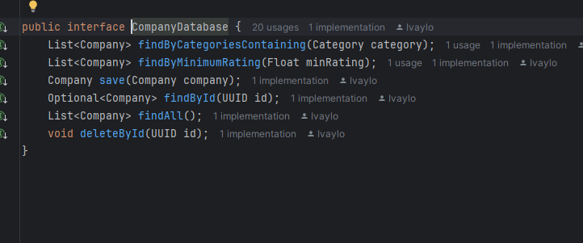

Protection Mechanisms
1.JPA Repository Methods:
- Uses prepared statements
- Automatic parameter sanitization
- Type-safe queries
2. Custom Queries:
- Uses JPQL instead of raw SQL
- Parameters bound using @Param annotation
- Example from DiningTableRepository:
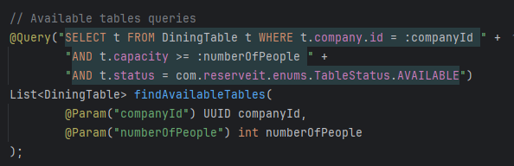

SQL Injection Test Case

If a user inputs a malicious SQL statement like:

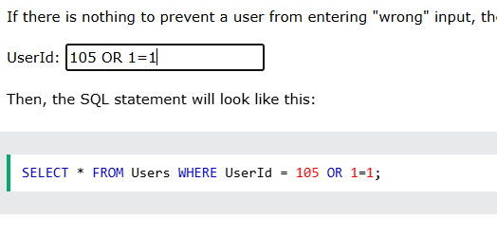

This would not execute because:
- JPA automatically escapes special characters
- Parameters are bound separately from the query
- Prepared statements prevent query structure modification

3. Cryptographic Failures (A02:2021)
Current Implementation

1.Password Hashing:
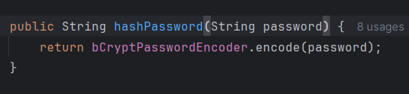
2.JWT Security:
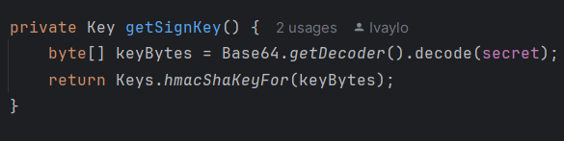
Areas for Improvement
- Add password complexity requirements
- Implement rate limiting for authentication attempts
- Add secure password reset functionality

4. Insecure Design (A04:2021)
Secure Design Patterns Used
- Authentication:
  - JWT-based authentication
  - Role-based access control
  - Token refresh mechanism
- Service Layer Abstraction:
  - Clear separation of concerns
  - Business logic isolation
  - DTO pattern for data transfer

Areas for Improvement
- Implement request rate limiting
- Add input validation at the DTO level
- Implement audit logging

5. Security Misconfiguration (A05:2021)
1. CORS Configuration:
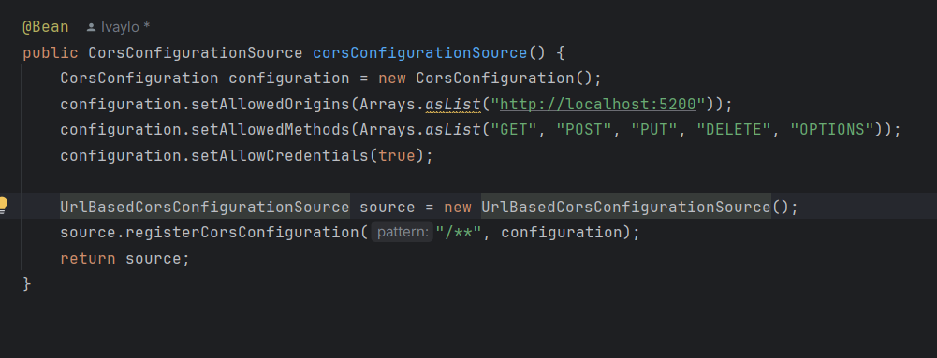
2. Security Headers:
- CSRF protection disabled
- No secure headers configuration

Recommendations
- Add security headers (X-Frame-Options, X-Content-Type-Options)
- Enable CSRF protection for non-API endpoints
- Implement proper error handling to prevent information leakage
6-10. Other OWASP Risks
Vulnerable and Outdated Components (A06:2021)
- Uses up-to-date Spring Boot version
- Dependencies managed through Gradle
Identification and Authentication Failures (A07:2021)
- Implements JWT authentication
- Password hashing with BCrypt
- Need to add password complexity requirements
Software and Data Integrity Failures (A08:2021)
- No integrity verification for uploaded files
- No digital signatures for data
Security Logging and Monitoring Failures (A09:2021)
- Basic logging implemented
- Need comprehensive audit logging
- Need monitoring system
Server-Side Request Forgery (A10:2021)
- No external URL processing
- Limited exposure to SSRF risks
Recommendations
- High Priority:
  - Implement user data access controls
  - Add comprehensive input validation
  - Enable security headers
  - Add rate limiting
- Medium Priority:
  - Implement audit logging
  - Add password complexity requirements
  - Enable CSRF protection
- Low Priority:
  - Add monitoring system
  - Implement file integrity checks
  - Add security scanning in CI/CD pipeline

